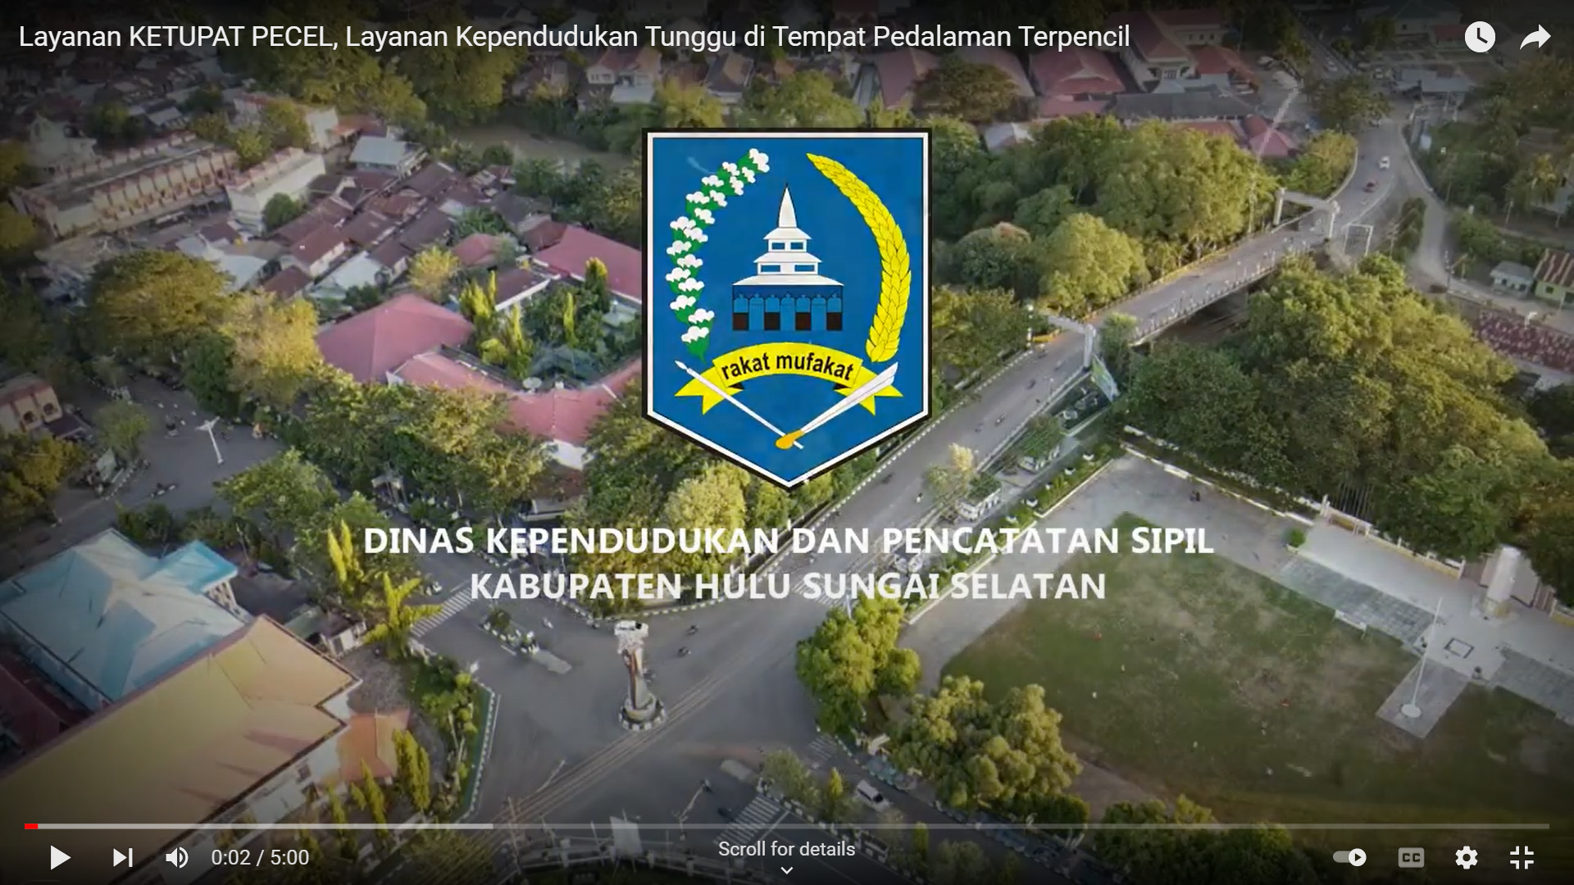

https://www.youtube.com/watch?v=xL7ETOfh2pY